Cloud Based DevOps Skill Assessment Application

1st Yogesh Mahajan
School of computer engineering and technology
MIT academy of engineering
Pune, India
mahajan.yogesh205@gmail.com
4th Nishant Kumar
School of computer engineering and technology
MIT academy of engineering
Pune, India
phy.nishant@gmail.com
2nd Roshan Patil
School of computer engineering and technology
MIT academy of engineering
Pune, India
roshanpatil3004@gmail.com
5th Amar More
School of computer engineering and technology
MIT academy of engineering
Pune, India
ahmore@comp.maepune.ac.in
3rd Chetan Pawar
School of computer engineering and technology
MIT academy of engineering
Pune, India
chetanpawar968@gmail.com

Abstract—Now a days many online tools are available to test the programming knowledge of the person like codechef. But in order to test the knowledge of the DevOps there is no such online tool available. So the goal is to develop the cloud based infrastructure to test the knowledge of DevOps of the examinee. The questions related to the DevOps will be given to the candidate along with the access to the terminal. The candidate has to do all the steps required to take care of the issue given. The terminal Provided to the candidate is the correspondence interface between the candidate and the allotted container. We are using containers rather than VMs, because containers are small,light-weighted and what's more, quick, one application can be pressed in every container image. The Kubernetes will deal with the containerized applications, for example, database stockpiling and client explicit order over a lot of containers or has and gives systems to sending, support, and application-scaling. The container runtime bundles, instantiates, and runs client directions on containerized application. The yield produced will be put away in an impermanent document which will be checked with the ideal yield put away in a database.
Keywords— DevOps, Orchestration, Containerization, Linux, Cloud computing, Parallel Computing, Networking.

Introduction
DevOps is an item progression framework that combines programming improvement with data advancement assignments . Its objective is to abbreviate the frameworks improvement stages while additionally conveying fixes, highlights, and updates every now and again in close arrangement .The DevOps approach is to incorporate robotization and occasion observing at all means of the product advancement .The attention on the engineer cooperation empowers another way to deal with dealing with the multifaceted nature of certifiable issues. It trust the tasks multifaceted nature stalls into a couple of classifications: setup the executives , foundation and arrangement mechanization, log and execution the board, and checking. The following are a few apparatuses we have used to help explain these errands.As a component of Agile changes as in the paper"Understanding DevOps and conquering any hindrance from continuous integration to continuous conveyance" [1] in recent years we have seen IT associations embracing continuous integration standards in their programming projects conveyance lifecycle, which has improved the effectiveness of advancement groups.. With the time it has been understood that this advancement as a component of ceaseless joining alone is simply not adequate to make the whole conveyance lifecycle proficient or isn't driving the associations efficiency.This paper attempts to cover all parts of Devops pertinent to different periods of SDLC and explicitly discusses business need, approaches to move from consistent combination to nonstop conveyance and its advantages.

Literature Review
Number of literatures pertaining techniques to DevOps and cloud computing published already and are available for public usage. According to Wotif Group [2]used DevOps standards to recuperate from the descending spirals of manual discharge exercises that numerous IT offices face. Its methodology included the idea of making it productive to do the working thing By characterizing the correct things (organization measures) for advancements and tasks groups and making it simple to receive, Wotif radically and viably improved the normal discharge process duration. Containerization is a lightweight virtualization arrangement.
The paper presented in conference 2017 Seventeenth International Conference on Advances in ICT [3], DevOps is stretched out from certain deft practices with a blend of examples planned to improve joint effort among advancement and task groups.
The principal explanation behind this paper is to direct an examination on how DevOps practice has affected to programming quality. The optional goal is to find how to improve quality efficiently. Automation is the most critical factor to improve the software quality. As per the results of multiple regression analysis, it has proved culture, automation, measurement and sharing are important factors to consider to improve quality of the software.
In the paper[7] Explores the market opportunities for cloud computing in India. The principal explanation behind this Cloud Computing is another worldview in data innovation (IT) and IT-empower services(ITES) that change processing as an asset to figuring as an administration. It is a problematic innovation with impact infesting over all part of a cutting edge economy.
In the paper presented in ”Euromicro Conference on Software Engineering and Advanced Applications” [4] DevOps and continuous practices are attracting steadily growing attentions by both practitioners and researchers in the software engineering community. The terms are regularly utilized conflictingly, reciprocally and with misty significance, in any case. By taking the positions that , this equivocalness and miscommunication renders the network incredible mischief, their belongings and interaction between them, decrease uncertainty.
GNU/Linux shell access through an internet browser for an inserted Linux e-learning framework [5] speaks to The web is developing quickly and more affects the training area than it had ever previously. This paper goes for depicting a novel method to expand the e-Learning procedures used to the zone of implanted Linux training. For these strategies, Open Source Software advancements, for example, AJAX, PHP, Apache have been utilized in an inventive manner to bestow inserted Linux instruction just by utilization of typical internet browsers which make the learning framework as simple as checking a mail. In this paper, methods for empowering the implanted gadgets Linux shell access through an internet browser is clarified, which is a key component of the framework. This improves adaptability and availability for numerous clients.
The paper addressed in Establish new plan to make evaluation course of action of examination questions and examination result. [6] This paper means to set up a sensible, objective, quantized assessment standard of breaking down examination and score, and build up the assessment list arrangement of examination questions and examination result dissecting. A ton of sensible and target thoughts, for example, examination trouble, gauge score, target trouble, etc are risen and characterized, and some related quantized estimation strategies are given, and the examination result breaking down and examination rule programming framework which can settle on a quantized choice is modified.
" Containerization and the PaaS Cloud " [9] center around Containerization is a lightweight virtualization arrangement.Aside from displaying benefits over customary virtual machines in the cloud, holders are particularly pertinent for PaaS mists to oversee and organize applications through compartments as an application bundling component.
" Task Based Automatic Examination System for Sequenced Test " [8] speaks to Computer extraordinarily impacts our instructive condition. Throughout the latest couple of years, online programmed PC examination frameworks have been generally utilized for PC based tests, however these frameworks depend on conventional inquiry answer examination style which isn't fit for the sequenced test. The sequenced test ought to consider the setting of the examinee.ex. the request of inquiries or the consents of the examinee, to review an examinee. This paper propose a compelling and viable programmed examination design dependent on assignment. The undertaking is to extract from the examination procedure and meet the solicitations of the sequenced test, for example, request and reliance.
Our Project is having appropriated condition. We are utilizing DevOps Tools, for example, Kubernetes for age of ace and slave nodes. System will perform task of the evaluation of skills of the candidate.

Methadology

Configuration Management
Configuration management tackles the issue of physically introduce and design bundles once the equipment is set up.

The advantage of utilizing configuration management arrangements is that servers are conveyed the very same way every time . In case you have to roll out an improvements crosswise over 100 thousand servers you just need to roll out the improvement in one framework . In the activities conditions we have worked in there were constantly exacting controls on who could get to generation condition , who could make change, when changes could be made, who could physically contact fittings , and who could get to what data centers . In these very directed and process situated undertakings the prospect of obscuring the lines among improvement and task appears like a non-starter.

Working of Kubernetes
To work with Kubernetes, we use Kubernetes API items to depict our bunches wanted state: what application or different outstanding tasks at hand we need to run, what container images we use, the quantity of imitations, what system and disk resources we need to make accessible, and more.The Kubernetes Master is a gathering of three procedures that keep running on the single node in our group, which is assigned as a master node.Those processes are: kube-apiserver, kube-scheduler and kubecontroller-manager.Each individual non-master node in our cluster runs two processes kube-proxy kublet.
C. Architectural Design
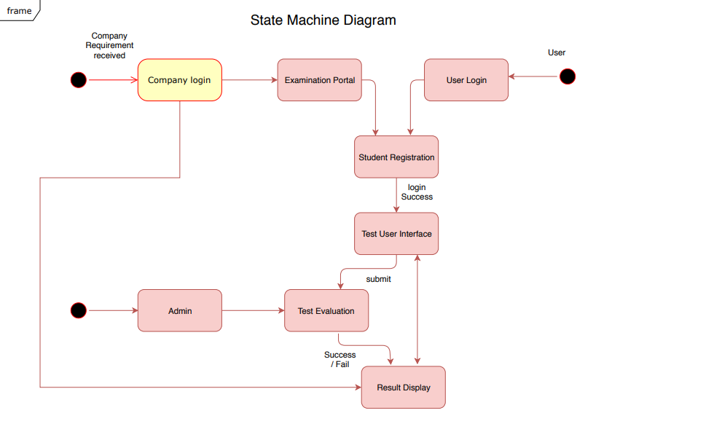

IV MATHEMATICAL MODEL
Input: X = Answers for the questions in the test.
• Output: Y = Relative rank of candidate according to his performance in the test.
Let S = {U, N, T, S, status, result, F}
Where, • U = { u1, u2, u3, .., ui.} Finite set of users (Candidates).
• N = { Master, Slave }
Where, Master = Kubernetes master node.
Slave = Kubernetes worker node.
• Slave = { slave1, slave2, ., slave i }
• T = { t1, t2, t3, ., ti } Finite set of test Scenarios.
- S = { s1, s2, s3, ., si } Finite set of scores of a user.
- • status = { status1, status2, .., status i } Test status. • Functionalities: Yes/No = authenticate (uname, passwd)
- Interface Candidate Web Brower (Wi)
- Si = get test Scenario Score(ti)
- Rank = apply ranking algorithm (ti, si)
- Result = generate test result.

V. Conclusion
Organizations that consolidate the DevOps activities to accomplish increasingly, plain and straightforward. With a single gathering made out of cross-valuable people all working in collaboration, DevOps structures can pass on the most extraordinary speed,value,and advancement. Companies that utilizes this application will be effectively ready to make test contingent upon their particular prerequisites.This test scenarios will help company to easily evaluate candidate knowledge and thus they can find a right candidate for the desired post

Acknowledgment
We would like to express our deep sense of gratitude and respect towards our guide Prof.Amar More, School of Computer Engineering, MIT Academy of Engineering.we have received from him while collecting data on this paper and throughout our studies. we whole-heartedly thank to our Dean Mrs. Ranjana R. Badre for their guidance. We also indebted to all Sr. Engineers and others who gave us their valuable time and guidance. The various information and sources we used during my report completion find place in our report.
REFERENCES

- Manish Virmani, “Understanding DevOps & bridging the gap from continuous integration to continuous delivery” Fifth International Conference on the Innovative Computing Technology ,20- 22 May 2015,Pontevedra, Spain. IEEE, 2015. Available: IEEE Xplore, https://ieeexplore.ieee.org/document/7173368 [Accessed: 03 August 2015].
- Matej Artac , Tadej Borovssak , Elisabetta Di Nitto , Michele Guerriero , Damian Andrew Tamburri, “DevOps: Introducing Infrastructure-asCode”39th International Conference on Software Engineering Companion (ICSEC), 20-28 May 2017, Buenos Aires, Argentin . Available: IEEE Xplore, https://ieeexplore.ieee.org/document/7965401 [Accessed: 24 August 2017].
- Pulasthi Perera , Roshali Silva , Indika Perera, “Improve software quality through practicing DevOps, 2017 Seventeenth” International Conference on Advances in ICT for Emerging Regions,6- 9 Sept. 2017,Colombo, Sri Lanka Available: IEEE Xplore, https://ieeexplore.ieee.org/document/8257807 [Accessed:15 January 2018].
- Daniel Stahl , Torvald Martensson , Jan Bosch, “Continuous practices and devops: beyond the buzz, what does it all mean?,”43rd Euromicro Conference on Software Engineering and Advanced Applications (SEAA),30 Aug.-1 Sept. 2017, Vienna, Austria Available: IEEE Xplore, https://https://ieeexplore.ieee.org/document/8114695 [Accessed:20 November 2017].
- Suchakrapani Datt Sharma , D. N Sonawane , Tanushri Chakravorty , Tushar Patil, “GNU/Linux shell access through a web-browser for an embedded Linux e-learning system” 3rd International Conference on Electronics Computer Technology,8-10 April 2011,Kanyakumari, India Available: IEEE Xplore, https://ieeexplore.ieee.org/document/5941713 [Accessed:07 July 2011].
- Zhang Ruilan , Hua Jing , Liu Yingjiu , An Weili “Establish new concept to develop evaluation system of examination questions and examination result” 2nd International Conference on Artificial Intelligence, Management Science and Electronic Commerce (AIMSEC), 8-10 Aug. 2011,Dengleng, China Available: IEEE Xplore, https://ieeexplore.ieee.org/document/6009959 [Accessed:06 September 2011].
- “Cloud Computing Innovation in India: A Framework and Roadmap - White Paper 2.0” 31 Dec. 2014,Pontevedra, Spain. IEEE, 2015. Available: IEEE Xplore, https://ieeexplore.ieee.org/document/7039186
- Song Luo,Jianbin Hu ,Zhong Chen, “Task Based Automatic Examination System for Sequenced Test” International Conference on Electronic Computer Technology, 20-22 Feb. 2009,Macau, China Available: IEEE Xplore, https://ieeexplore.ieee.org/document/4795912 [Accessed:27 February 2009].
- Claus Pahl, “Containerization and the PaaS Cloud”, IEEE Cloud Computing , Volume: 2 ,Page(s): 24 - 31, Issue: 3 , May-June 2015 , Available: IEEE Xplore, https://ieeexplore.ieee.org/document/7158965. [Accessed:15 July 2015].

